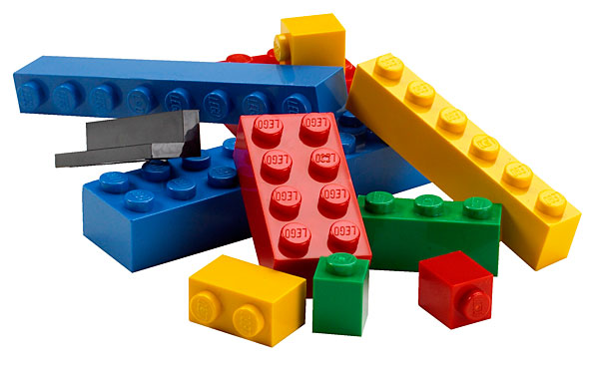
First weekend in August! Drop off your Pre-Built creation on Friday August 3 between 3pm & 5pm. Prizes awarded Sunday August 5 at 5pm after voting closes!
Marine City Maritime Days Lego Contest!!!!
Create an original Lego model that is inspired by our nautical neighbornood!
Create your own, with your family or with your friends!

Two prizes will be awarded! One category for kids
12 years old and under; one for participants 13-17.
Voting boxes will be placed in front of your entry all
weekend and anyone can vote! 25 cents per vote!
Lego creations should not exceed 24” by 24” in size.

Entry Fee is $10.00 made payable to the $150 prize for
Maritime Days Festival each age group!

Rules:
- Entry form and $10 fee must be received by July 15, 2018.
- Participants must provide their own Lego bricks.
- Entries must be of your own creation, not a Lego kit.
- All entries must be completed upon arrival.
- Your creation must not exceed 24” x 24” in size.
- Teams will compete for a single prize.
- Provide a 3 x 5 card with your name, age, and one sentence describing your creation.
- All entries must be taken home by 6pm on Sunday August 5, 2018.
- Disclaimer: LEGO is a trademark of the LEGO Group of companies which does not sponor, authorize or endorse this contest.
- For more information, email us at: info@maritimedays.com

All forms must be received by July 15, 2018
Marine City Maritime Days Lego Contest Entry Form
Names and ages of all team members: (age of oldest team member determines category placed.)
___________________________________________________________________
___________________________________________________________________
___________________________________________________________________
___________________________________________________________________
___________________________________________________________________
Address: ___________________________________________________________________
City:____________________State:_____________________Zip_______________
Phone Number___________________________Email____________________________
Brief Desctription of creation:__________________________________________
___________________________________________________________________
Mail Entry Form and Fee to: Marine City Maritime Days Festival
P O Box 192
Marine City, Mi. 48039
Make Checks Payable to: Maritime Days Festival

