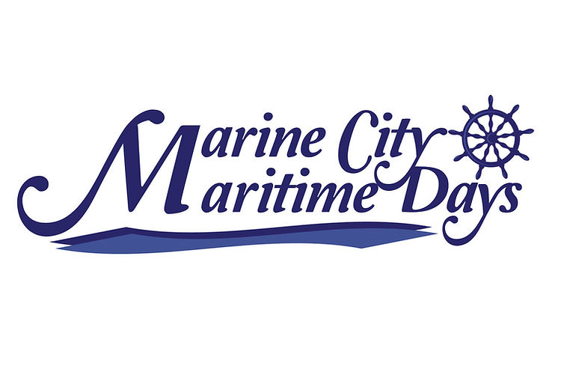
Marine City Festival, Inc.
Contact Information: Emily Hendrix
Cell Phone: 2489048501
Email: Hendrix.emily13@gmail.com
Empowered Nutrition: 6734 River Road, Marine City

2023 SPONSORSHIP AND DONATION FORM
EVENT DAYS: AUGUST 4TH – 6TH
FAMILY SPONSOR: $100
- Name on our family sponsor board displayed at event all weekend.
SMALL BUSINESS SPONSOR: $250
- Name of business on Marine City Maritime Day website and social media
- Option to donate a coupon, business card, etc into our small business bags which will be handed out to every person at the event.
- A sign with your name and logo on it displayed at the festival
BRONZE SPONSOR: $1,000.00
- Name on festival shirt
- Name and logo on banner displayed in beer tent.
- Free entry to the parade + 5 wristbands for free entry into beer tent all weekend.
- Name displayed on Sponsor Board + on Maritime social media.
SILVER SPONSOR: $2500.00
- Name on festival shirt
- Name and logo on banner displayed in beer tent.
- Free entry to parade + 10 wristbands for free entry to beer tent all weekend.
- Name and Logo on a sign displayed for 6 weeks at Music at the Park.
- Name on beer koozies
- 1 free vendor space day of event for display of business services
- Name displayed on Sponsor Board
- Name of business on Marine City Maritime Day website and social media

GOLD SPONSOR: $5,000.00
- Main sponsor of event- Name AND logo on festival shirt
- Name and logo on banner displayed at main stage of event.
- Free entry to parade + 20 wristbands for free entry to beer tent all weekend.
- Name and logo on sign displayed for 6 weeks at Music at the Park
- Name AND logo on beer koozies
- 2 free vendor spaces day of event for display of business services
- Name displayed on Sponsor Board
- Name of business on Marine City Maritime Day website and social media
- Recognition throughout festival as GOLD Sponsor!
- Highlighted at Main Sponsor on schedule of events.
- Large fireworks sponsor! Recognition at fireworks show!

THANK YOU FOR YOUR SPONSORSHIP! We are looking forward to promoting your business + creating an amazing event.

Business Name: ______________________
Contact name: ________________________
SPONSORSHIP LEVEL: ____________________
Business Address:______________________
Phone Number: ________________________
Email: ________________________________
Business/Family Name to be advertised: _______________________________________
PLEASE SEND NAME DISPLAY + LOGO TO Hendrix.emily13@gmail.com if your donation includes logo printed on shirt/banner/sign.
ALL SPONSORSHIP FORMS MUST BE COMPLETED AND RETURNED TO EMILY HENDRIX BY MAY 8TH 2023
MAIL COMPLETED FORM AND CHECK TO EMPOWERED NUTRITION
6734 RIVER ROAD, MARINE CITY 48039

