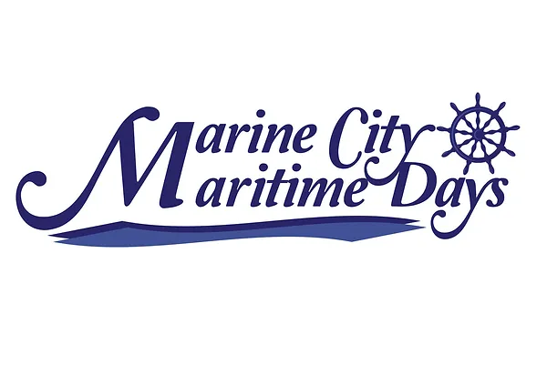
Miss Maritime Days 2024

Applicant Information
Name:___________________________________ Phone: ______________
Home Address:_________________________________________________
Date of Birth:_______________ Email:_______________________
School:_______________________________ Grade:____________
Describe Yourself
Hobbies/Interests:____________________________________________
Sports:________________________________________________________
Community Service:___________________________________________

Parent/Legal Guardian Name (if applicant is under 18)
Name:_________________________________________________________
Home Address:________________________________________________
Email:_________________________________________________________
Phone Number:________________________________________________
How it works
Voting boxes including photos of the first 25 eligible applicants will be placed around Marine City. The applicant that receives the most monetary donations will be crowned Miss Maritime Days 2024. The 2 applicants with the next highest amounts will be selected as Queens Court members and will accompany the Queen in the Parade taking place on August 4, 2024. Miss Maritime Days will receive a cash prize totaling 40% of the amount collected in the donation boxes. The Queen’s Court members will each receive a cash prize totaling 10% of the amount collected in the donation boxes.
Eligibility Requirements
Applicant must be between the ages of 14-18 as of August 2, 2024.
Applicant must be a student at Marine City Middle School/High School. If homeschooled, home address must be within Marine City/Cottrellville/China/East China zip codes.
Applicant must be present at the crowning ceremony taking place at 7:30 pm on Friday, August 2, 2024.
Applicant must be available to participate in the Maritime Days Parade on Sunday, August 4, 2024 and the Marine City Holly Jolly Christmas Parade, typically held the Tuesday prior to Thanksgiving (November 26, 2024).
**Completed application and clear photo of the applicant only must be received by 11pm, 04/30/2024. Please email both the application and photo to missmaritimedays@gmail.com. Please contact Ellen Binkley with questions, 734.244.3214.**
Consent
I hereby agree and declare that I am the parent/legal guardian of the above named applicant and consent to my child’s participation in the 2024 Miss Maritime Days contest, including all eligibility requirements. I agree to allow Maritime Festival Inc. to use my child’s likeness for contest voting and future marketing campaigns in both digital and print form.

Applicant Signature:____________________________________________________
Parent/Legal Guardian Signature:______________________________________

