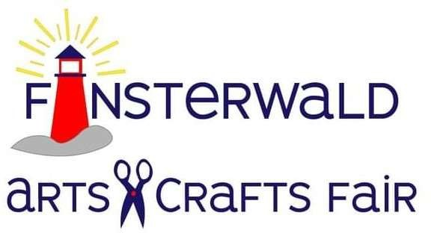
August 5th & 6th, 2023 300 Broadway, Marine City, MI Sponsored by Friends of City Hall finsterwaldac@gmail.com

Juried Arts & Crafts Fair 2023
Saturday August 5th, 10am – 6 pm, and Sunday August 6th, 10am – 4 pm
Name Address _City State Zip Email Phone _ Web Site
Electricity required? Y N Handicapped Parking? Y N Number of booths required (booth size 10’ x 10’, $60.00 fee per booth)

_Silk/Dried Flowers
_Blown Glass
Stained Glass _ Sculpture/Pottery
Decorated Clothing _ Knit/Crocheted

_Painting
Candles/Soap
Other-Please Specify

_Woodcrafts _Jewelry _ Description
- Please include (1-2) photos of your work and (1) photo of your setup. Photos will be returned the weekend of the festival.
- This is a juried event. Only original arts & crafts will be allowed. No kits, commercial items or flea market wares. Each exhibitor will be checked prior to the show opening.
- Security will be furnished during the hours the show is closed, but we will NOT be liable for losses or damages occurring on the grounds.
- Vendors can set up Friday (August 4th) from noon – 8 pm and Saturday (August 5th) from 7-10 am. The festival is outdoors, so please provide your own tent.
- Please return this registration form, photos and booth fee, payable to Friends of City Hall. Please mail to Sarah Polio, 434 Holland St, Marine City, MI 48039. A confirmation will be emailed to you. Final details along with a Booth Number will be emailed to you approximately one (1) week prior to the event.
If you have any questions, please call Sarah Polio at (586)713-6530 or email at finsterwaldac@gmail.com. EXHIBITOR’S SIGNATURE DATE
I understand that Friends of City Hall and the City of Marine City are not responsible for any losses or damages to work, personal injury or property damage, nor will I be a party to any legal action against them, and I further agree to hold them harmless. I also consent to use of my name, photos and biographical information in any promotional items.

